# Quiz Game

### A MINI PROJECTREPORT

#### Submittedby

#### Group/project-Group No: G17/T1

**NAME:-Divyansh Wadhwa , Rollno:-2310991569**

**NAME:-Gagandeep Singh, Rollno:-2310991572**

**NAME:-Garv Gupta, Rollno:-2310991573**

**NAME:- Gaurav Singh Heer, Rollno:-2310991574**

#### in partial fulfillment for the award of the degree of

## BACHELEOR OF ENGINEERING

***in***

COMPUTER SCIENCE & ENGINEERING



**CHITKARA UNIVERSITY**

**CHANDIGARH-PATIALA NATIONAL HIGHWAY**

**RAJPURA (PATIALA) PUNJAB-140401 (INDIA)**

##### october &2023

###### TABLE OF CONTENTS

|  |  |  |
| --- | --- | --- |
| Sr.no | Section | Page no |
| 1 | Details | 1 |
| 2 | Introduction | 3 |
| 3 | Problem Statement | 4 |
| 4 | Technical Details | 5 |
| 5 | Key Features | 6 |
| 6 | Project Highlights | 7-14 |
| 7 | Bonus Feature | 15 |
| 8 | Conclusion | 16 |

**Abstract**

A quiz game is a dynamic and interactive web application designed using HTML CSS and JAVASCRIPT to engage users in a fun and educational activity. The game involves single -choice questions and provides instant feedback on their answers. The user interface is crafted using HTML for structuring the content, CSS for styling and JAVASCRIPT add interactive behaviour to web pages.HTML is utilized to create the structure of the quiz game. It defines various elements such as buttons, questions, options, and score display. Each question and its corresponding answer choices are structured using HTML elements like headings, paragraphs, lists, and buttons. The layout is organized to provide an intuitive and visually appealing interface.CSS is employed to enhance the aesthetics of the quiz game by styling HTML elements. This includes defining colors, fonts, spacing, and layout arrangements to create a cohesive and engaging design. CSS rules are applied to format the text, add backgrounds, set margins and paddings, and align the elements within the webpage. The quiz game operates by presenting questions to the user and allowing them to select an answer. JAVASCRIPT is used upon submission, the chosen answer is evaluated, and immediate feedback is displayed to inform the user if the answer is correct or incorrect. The use of CSS, HTML and JAVASCRIPT altogether enables a seamless and interactive user experience, enhancing engagement and enjoyment during the quiz game.

**1.Introduction**

A quiz game is an interactive and engaging activity designed to test a person's knowledge or expertise on a particular topic or a variety of subjects. It typically involves a series of questions or challenges posed to the participants, who are required to provide answers or solutions within a limited timeframe. Quiz games are often used for entertainment, education, and as a means of competition. Quiz games consist of a series of questions or challenges. These questions can vary in complexity, covering a wide range of topics, from general knowledge and trivia to specific subjects like history, science, or pop culture. Quiz games have specific rules that dictate how participants can answer questions, earn points, and possibly win the game. These rules often include time limits for answering questions, scoring systems, and regulations regarding incorrect answers. Quiz games are typically competitive in nature. Participants or teams compete against each other to answer questions correctly and accumulate points. The player or team with the highest score at the end of the game is often declared the winner. Quiz games come in various formats, including board games, television game shows, online and mobile apps, and live trivia events. The format can vary from multiple-choice questions to open-ended queries, and participants may play individually or in teams. Quiz games serve as both a form of entertainment and an educational tool. They offer a fun way to test and expand one's knowledge while also providing an opportunity for social interaction and friendly competition. In many quiz games, there is a host or moderator who presents the questions, enforces the rules, and often adds an element of entertainment to the game through their presentation style and commentary. some quiz games offer prizes or rewards to the winners. These can range from cash prizes to certificates, virtual badges, or simply the satisfaction of winning. Quiz games are popular in various settings, from schools and educational institutions to entertainment venues and online platforms. They provide an excellent way to engage, challenge, and entertain participants while promoting the acquisition of knowledge

**2. Problem statement**

**Question Balance**: Maintaining the right level of difficulty in questions can be tricky. If questions are consistently too hard, players get discouraged; if too easy, players lose interest.

**Repetition:** Repeated questions can lead to player boredom and frustration, especially in games with limited question pools.

**Inclusivity:** Some quiz games may not cater to a diverse audience, with questions favoring specific demographics or cultures.

**Technical Issues:** Technical glitches such as server crashes, connectivity problems, and software bugs can disrupt the gaming experience.

**3. Technical Details**

**1. User Engagement**: A successful quiz website can attract a large and engaged user base. Users will spend time on the website, attempting quizzes, and returning for more, leading to increased user engagement.

**2. Educational Value:** Depending on the content and focus of your quizzes, the website can become a valuable educational resource. Users can learn new facts, improve their knowledge, and even develop new skills, especially if you offer quizzes in various educational fields.

**3. Entertainment:**Many users visit quiz websites for fun and entertainment. Well-crafted quizzes with engaging questions and interactive features can provide hours of enjoyment.

**4. Community Building:**By incorporating features like user profiles, leaderboards, and social sharing, the website can foster a sense of community among users. Competitions, achievements, and user-generated content can further strengthen this aspect.

**5. Monetization:** A successful quiz website can be monetized in various ways. You can generate revenue through advertising, premium subscription models, or by selling sponsored quizzes.

**6. Data Insights:**Your website can collect valuable data on user behavior, preferences, and quiz performance. This data can be used for further content optimization, targeted marketing, and improving the user experience.

**7. Brand Visibility:** If well-promoted and marketed, the quiz website can boost your brand's online presence and reputation. Word of mouth and social sharing can also help in brand visibility.

**8. Learning Analytics:** For educational quiz websites, you can gather insights into how users learn and perform. These analytics can help improve the quality of educational content and instructional methods.

**9. Innovation and Growth:** Over time, the project can evolve with the addition of new quiz types, features, and functionalities. You can continue to innovate and grow your user base.

**10. Feedback and Iteration:** Through user feedback and analytics, you can continuously refine and improve the website. This iterative process can lead to a more user-friendly and content-rich platform.

**3. Key Challenge**

**2.1 .Balancing Difficulty:** Striking the right balance between questions that are challenging and questions that are accessible to a wide range of players can be difficult. If questions are consistently too hard or too easy, it can lead to player frustration or boredom.

**2.2. Question Repetition:** Keeping a large pool of unique questions is a challenge. Repeated questions can make the game feel monotonous and reduce player engagement.

**2.3. Cheating and Spoilers:** In multiplayer games, preventing cheating through external resources or communication with other players is a challenge. Cheating can undermine fair competition.

**2.4 Inclusivity:** Crafting questions that are inclusive and not biased toward a specific demographic, culture, or region can be challenging. Ensuring that the gameappeals to a diverse audience is essential.

**2.5 Technical Issues:** Like any digital game, quiz games can experience technical problems such as server crashes, connectivity issues, or software bugs, which can disrupt the player experience.

**2.6 Content Updates:** Keeping the game's content up-to-date can be challenging, especially in rapidly evolving fields like technology and pop culture.

**2.7 Educational Depth**: Providing substantive educational content that goes beyond surface-level knowledge can be difficult, especially when trying to balance fun and learning.

**2.8 Unbalanced Competition:** In multiplayer modes, players with different levels of knowledge can compete against each other. Ensuring a fair and balanced competitive environment can be challenging.

Addressing these challenges requires thoughtful game design, continuous content updates, strong community management, and an understanding of the player base. Developers must work to create an enjoyable, inclusive, and fair quiz gaming experience for all participants.

**4. Key Features**

**4.1 Diverse Categories**: A wide range of question categories, from general knowledge to specific topics like sports, history, science, and pop culture.

**4.2 Single and Multiplayer Modes:** Options for solo play or challenging friends and other players in multiplayer modes.

**4.3 Dynamic Question Generation**: Questions that change every time you play, preventing repetition and keeping the game engaging.

**4.4 Progress Tracking**: Player statistics and achievements to monitor performance and improvement over time.

**4.5 Lifelines and Power-ups**: Tools like lifelines or power-ups to assist players when faced with challenging questions.

**4.6 Educational Content:** A balance of fun and educational questions to help players learn new facts and expand their knowledge.

**4.7 Accessibility:** Availability on various platforms, including mobile devices, tablets, and computers, for on-the-go or at-home play.

**4.8 Customization:** Options to customize the game, such as selecting question difficulty, time limits, or question categories.

**4.9 Leader boards:** A leader board system to track and compare scores with other players, encouraging healthy competition.

**4.10 Offline Play:** The option to play offline, allowing users to enjoy the game without an internet connection.

**4.11 Regular Updates**: Continual addition of new questions and content to keep the game fresh and up-to-date.

**5. Project Advantages**

**5.1 Enhanced Learning:** Quiz games can be highly educational. They encourage players to learn and retain new information across various topics, from history and science to pop culture.

**5.2 Interactive Engagement:** Quiz games actively engage players by requiring their participation, thinking, and decision-making. This interactivity enhances the learning experience.

**5.3 Improvement of Cognitive Skills**: Playing quiz games can improve cognitive functions such as memory, problem-solving, critical thinking, and decision-making.

**5.4 Competition and Motivation**: Quiz games often involve competition, whether against other players or oneself. Competition can be a strong motivator for learning and personal improvement.

**5.5 Entertainment and Fun:** Quiz games are enjoyable and provide a fun way to spend leisure time, whether alone or with friends and family.

**5.6 Social Interaction:** Multiplayer quiz games encourage social interaction and friendly competition, promoting social bonding and communication.

**5.7 Quick Thinking:** Quiz games often require players to think on their feet, answer questions within time limits, and make fast decisions, improving quick-thinking skills.

**5.8 Self-Assessment:** By tracking their performance and scores, players can self-assess their knowledge and identify areas where they need improvement.

**5.9 Versatile Accessibility:** Quiz games are available on various platforms, including mobile devices, making them accessible and convenient for players to enjoy anywhere.

**5.10 Stress Relief:** Playing quiz games can provide stress relief and relaxation by diverting attention from daily worries and promoting mental engagement.

**5.11 Promotes Healthy Debate:** Multiplayer quiz games can spark healthy debates and discussions among players, as they compare answers and share their knowledge.

**5.12 Continual Challenge:** The dynamic nature of quiz games means that players face new challenges with each session, preventing monotony and boredom.

**5.13 Goal Achievement:** Achieving high scores or completing challenges in quiz games can provide a sense of accomplishment and motivation to continue playing.

**5.13 Boosts General Knowledge:** Quiz games expose players to a wide range of topics and facts, contributing to their general knowledge.

**5.14 Personalized Learning:** Some quiz games offer personalized experiences, adapting to the player's level of knowledge and providing tailored challenges.

Overall, quiz games offer a multifaceted experience that combines education, entertainment, and personal growth. They are an excellent tool for both learning and leisure, catering to a broad range of interests and ages.

**6. Bonus Feature**



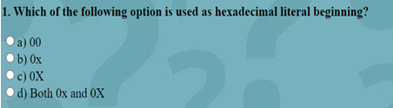

### NORMAL

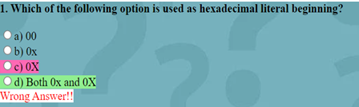

**ON CLICK AT OPTION**

**7. RESULT**

**Grade**

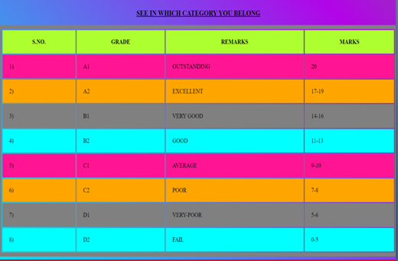

**Normal Mode Quiz Game**



**For width 801-1500px for width 501-800px**

 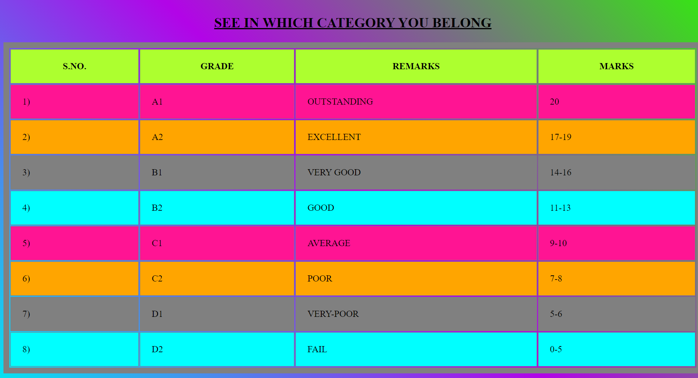

**For width 150-500px for width 801-1500px**

**Comfort Mode Quiz Game**

** **

**For width 801-1500px**  **For width 501-800px**



**For width 100-500px**

**Night Mode Quiz Game**

 

**For width 801-1500px For width 501-800px**



**For width 100-500px**

**Solution Tab**

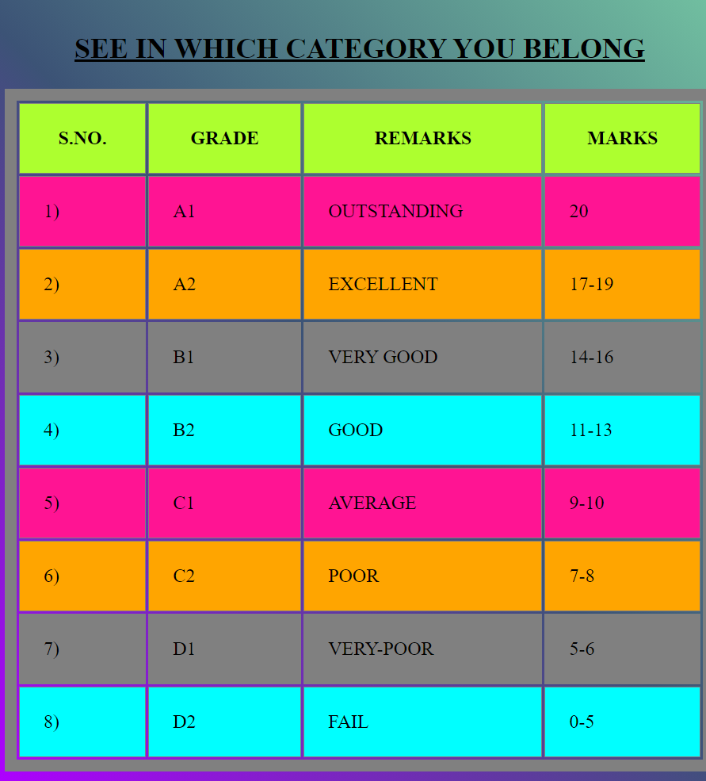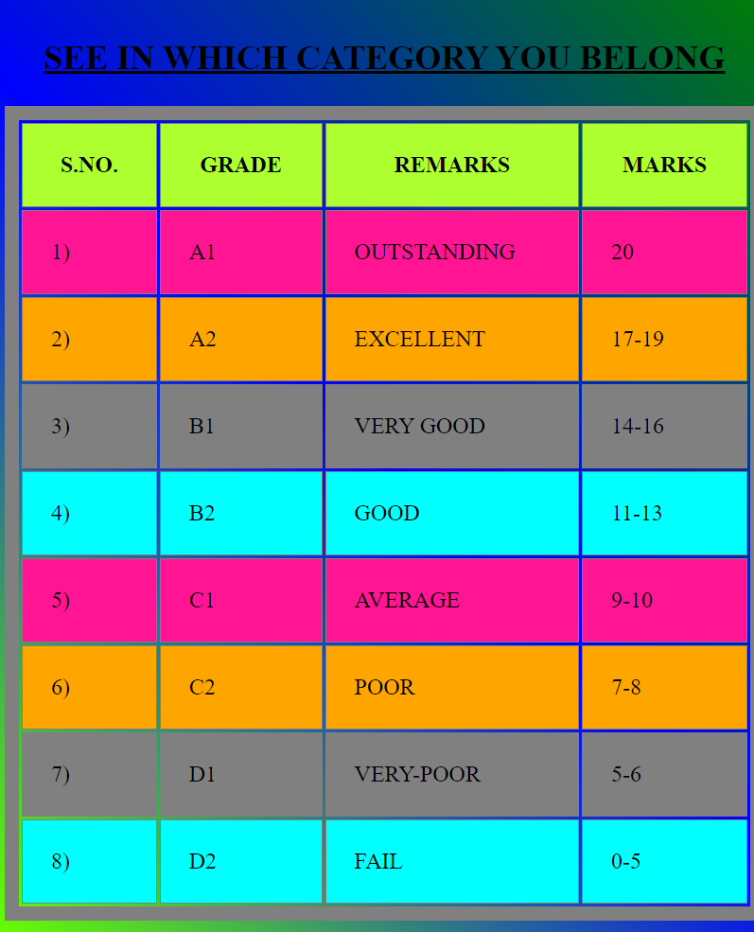

**For width 601-801px For width 150-600px**

**Conculsion**

Quiz games are a captivating and multifaceted form of entertainment and education. They offer a wide array of advantages, from enhancing learning and cognitive skills to promoting social interaction and friendly competition. The interactivity of quiz games engages players actively, fostering quick thinking and problem-solving abilities. Additionally, these games provide a source of entertainment and relaxation, serving as a stress reliever and a means to unwind from the challenges of daily life.

Quiz games are accessible on various platforms, making them convenient for players to enjoy at their leisure, and they cater to a diverse range of interests and knowledge levels. Furthermore, these games encourage continual self-assessment, goal achievement, and the pursuit of personal growth.

The dynamic nature of quiz games ensures that they remain fresh and engaging, offering new challenges with each session. As an educational and fun tool, quiz games contribute to the expansion of players' general knowledge and can be a catalyst for stimulating healthy debates and discussions among participants.

Ultimately, quiz games are more than just a form of entertainment; they represent a fusion of learning, competition, and enjoyment. They continue to be a popular choice for individuals of all ages, providing an opportunity to enrich one's knowledge while having a great time.

Top of Form